Practical 2: Implement the RSA algorithm for public-key encryption and decryption, and explore its properties and security considerations.
CLI OUTPUT
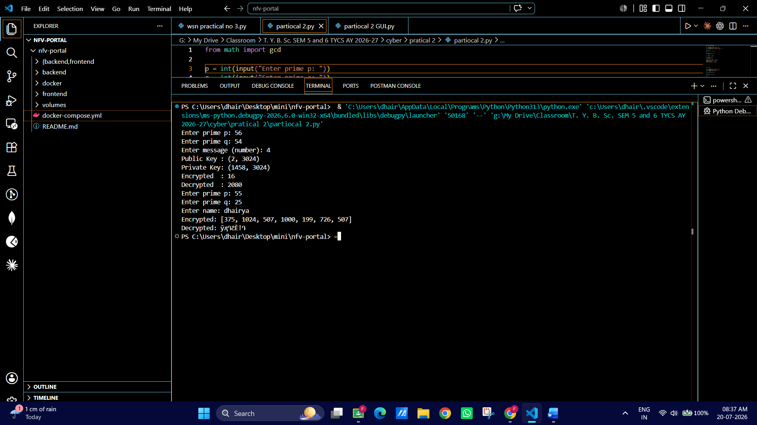
GUI OUTPUT:
